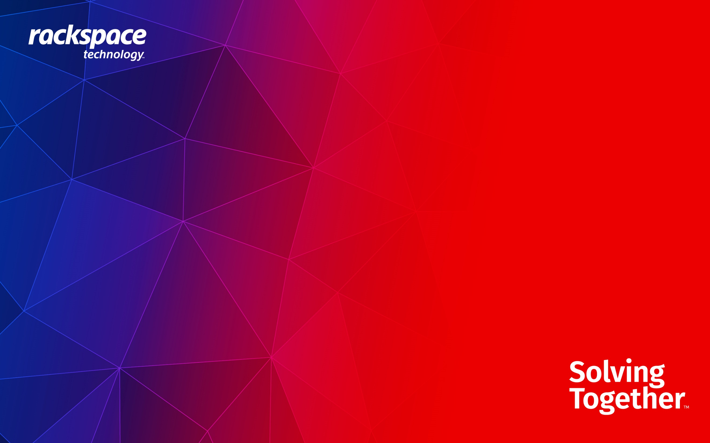

AWS Landing Zone
Detailed Design Document


Prepared for: Adrenalin Media Pty Limited
Prepared by: Ashu Rana on the behalf of Rackspace
Table of Contents
1 Document Control 3
1.1 Revision History 3
2 Introduction 4
3 Landing Zone 5
3. 1 High Level Design 5
4 Low Level Design 6
4.1 Control Tower 6
4.2 Organizational Unit (s) (OU) 7
4.3 Organizational Units Structure 7
4.3.1 Management Account: 7
4.3.2 Root OU: 8
4.3.3 Production OU 8
4.3.4 Non-Production OU 9
4.3.5 Common OU 9
4.3.6 Security OU 9
5 Naming convention 11
5.1 Account Names 11
5.2 Containers/Compute 11
5.2.1 Elastic Container Service (ECS) 11
5.2.2 Application Load Balancer 11
5.3 Networking 11
5.3.1 Virtual Private Cloud (VPC) 11
5.4 Storage 11
5.4.1 Simple Storage Service (S3) 11
5.5 Default Naming 11
6 Identity & Access Management 12
7 Networking 12
7.1 VPC 13
7.2 Private Subnet 13
7.3 Internet Gateway 13
7.4 Public Subnet 13
7.5 Availability zones 14
7.6 VPC 14
7.7 Subnets 14
8 Tagging Strategy 15
9 Logging and Monitoring 17
9.1 Introduction 17
10 Backup 17
10.1 Available Services Overview 17
11 Infrastructure as Code 17
11.1 Execution Flow 18
12 Resource Specification 19
13 Exclusions 21

Document Control

Revision History
Version | Date | Author | Comments
0.1 | 23 May 2024 | Ashu Rana | Landing Zone and Deployment Pipeline

Introduction
The Amazon Web Services Platform (AWS) provides Adrenalin Media Pty Limited with a robust framework characterized by scalability and high performance to accommodate various business workloads.
Enclosed is a comprehensive document outlining the architectural approach and design rationale pertaining to the AWS Account structure, security protocols, deployment strategies for backend applications utilizing AWS ECS, and the implementation of Maria DB within the data layer using the Bitbucket Terraform pipeline. This document primarily focuses on the initial phase, delineating the establishment of the AWS Account structure and infrastructure provisioning.
This phase facilitates hands-on skill development and exposure for Adrenalin Media Pty Limited teams, thereby validating the efficacy of the new platforms through tangible proof of value, ultimately informing strategic outcomes.
Additionally, this document delineates the architectural and design processes relevant to the AWS landing zone, encompassing various parameters essential for deploying resources on public cloud services.

The main requirements for the “landing zones” have been generated from the high-level proposals in the following table:
Reference | Requirement
R001 | The Landing zone shall cover the AWS environment
R002 | The Landing zone shows the account structure.
R003 | The Landing zone will be implemented using the Control Tower without any customization.
R004 | The architecture shall be the blueprint for the foreseeable future of Adrenalin Media Pty Limited.

The following design decisions have informed the design process.

Reference | Requirement
D001 | AWS's primary region will be Sydney – ap-southeast-2, For Low latency, direct costs, and data transfer costs.
D002 | Environments will be separated by accounts (Development, UAT, Production)
D003 | Environments will be separated by VPCs within the different accounts.
D004 | Environments will be separated by Organizational Units (PROD OU, NON-PROD OU)
D005 | Additional Organizational Units will be SECURITY OU and COMMON OU
D006 | Landing Zone will be implemented using Control Tower Manually.
D007 | Bitbucket will be used for source code management.
D008 | All three environments will be provisioned through IaC using Terraform and bitbucket pipelines. (Control Tower will be provisioned manually)
D009 | AWS Backup will be within the same account and region (wherever applicable)
D010 | AWS secret manager, CloudWatch, s3, DynamoDB will be used to support the provisioning.
D011 | The control tower will be used with the home region set to Sydney (ap-southeast-2).
D012 | Maria DB will be used for data layer.
D013 | Backend service will be deployed on ECS Fargate exposed through Application Load Balancer.
The following are Risk Assumption issues and dependencies.
Reference | Requirement
RI01 | Decision on Certificate is pending on the customer whether to use AWS certificate manager or external to provide https endpoints.

Landing Zone

3. 1 High Level Design
Below diagram shows the AWS landing zone estate for Adrenalin DEIT.

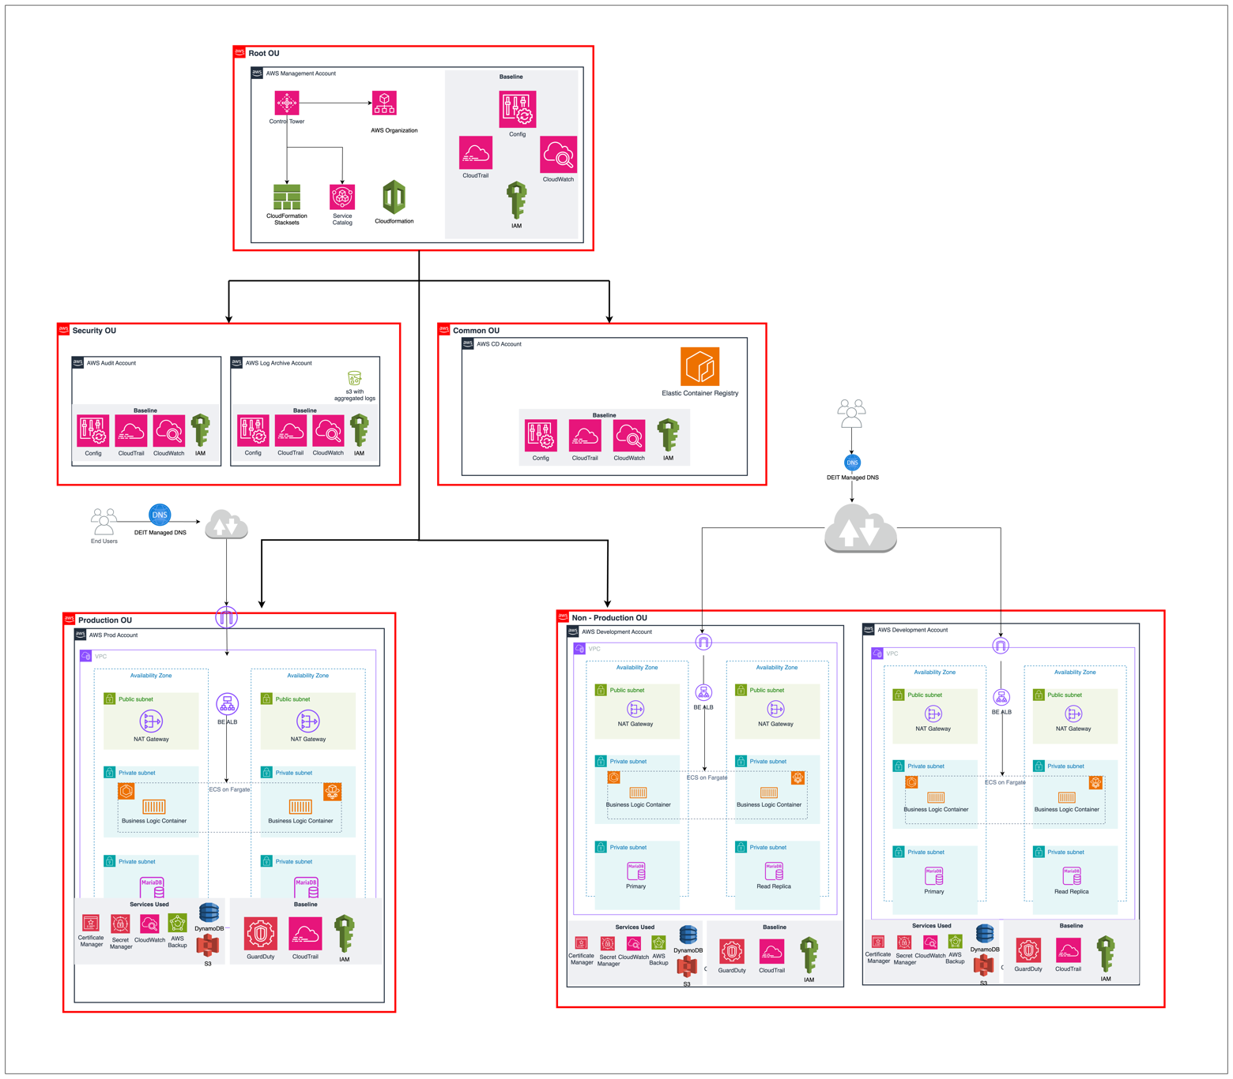

Figure 1: High Level LZ Design

The following high-level design illustrates the Landing Zone (LZ) architecture established for Adrenalin DEIT. This structured and secure multi-account AWS environment is organized into four main Organizational Units (OUs): Security, Common, Prod, and Non-prod.
1. Organizational Units (OUs):
- Security OU: This OU is dedicated to maintaining security and compliance across the AWS environment.
  - Audit Account: The Audit account within the Security OU is responsible for auditing and monitoring activities across all accounts, ensuring compliance with internal policies and regulatory requirements.
  - Log-Archive Account: Acting as a centralized repository, the Log-Archive account collects and stores security logs from various sources. This account ensures the integrity and availability of log data for security monitoring and forensic analysis.
- Common OU: The Common OU includes shared resources and services that are utilized across multiple environments.
  - CD Account: The Continuous Deployment (CD) account houses the Elastic Container Registry (ECR), which stores Docker images used in application deployments. This centralized container repository supports efficient and consistent deployment processes.
- Prod OU: The Production (Prod) OU is designated for hosting production workloads.
  - All application workloads within this OU will be deployed on Amazon ECS Fargate, providing a serverless container orchestration service that enhances scalability and reduces operational overhead.
  - MariaDB is used as the primary database in the Prod account, providing a reliable and high-performance relational database solution for production applications.
- Non-prod OU: The Non-production (Non-prod) OU is intended for Development and UAT environment
  - Similar to the Prod OU, this OU hosts all application workloads on ECS Fargate and Maria DB as database, ensuring a consistent and scalable environment for development and testing purposes.
2. Environment Hosting:
- ECS Fargate: Both the Prod and Non-prod OUs utilize Amazon ECS Fargate to host application workloads. ECS Fargate offers a serverless way to manage containers, allowing Adrenalin DEIT to focus on building and deploying applications without managing the underlying infrastructure.
3. Centralized Services and Security:
- Centralized Logging: By consolidating logs in the Log-Archive account within the Security OU, Adrenalin DEIT ensures robust logging practices. This centralized logging approach facilitates effective monitoring, security analysis, and compliance auditing.
- Continuous Deployment: The CD account in the Common OU, with its ECR repository, supports the continuous integration and deployment pipeline. This setup enhances development efficiency and ensures consistent deployment of containerized applications.
4. Flexibility and Scalability:
- The structured OU design provides flexibility to accommodate growth and changes in organizational requirements. By segregating production and non-production environments, Adrenalin DEIT can manage resources more efficiently and maintain clear operational boundaries.
Standard Landing Zone will be set up for Adrenalin DEIT.

Low Level Design

Control Tower
AWS Control Tower is a comprehensive service designed to simplify the setup and governance of a secure, multi-account AWS environment, based on established best practices. It provides organizations with a way to automatically provision new AWS accounts and organize them into a well-architected framework, enforcing compliance and security policies while enabling scalability and operational efficiency.

- Automated Account Provisioning: Streamlines the process of creating and configuring new AWS accounts, ensuring they adhere to organizational policies and best practices from the outset.
- Centralized Governance: Offers a unified dashboard for governance, allowing centralized monitoring and management of compliance, identity, and access across all accounts within the AWS environment.
- Policy Enforcement: Utilizes pre-packaged governance rules and policies, known as Guardrails, to automatically enforce compliance and security standards, reducing the risk of configuration errors and policy violations.
- Customization and Scalability: Supports customization to meet specific organizational needs while providing a scalable framework that grows with the organization, facilitating efficient management of resources and accounts.

For Adrenalin DEIT, AWS Control Tower will be configured to govern a primary region ensuring operational continuity and data integrity across the organization's AWS environment. The designated region is Sydney – ap-southeast-2

Organizational Unit (s) (OU)
An OU is a group of AWS accounts within an organization. You can organize your accounts into OUs based on your business requirements. For example, you can have OUs for different departments, projects, or environments (like dev, test, and prod). OUs can also contain other OUs, giving you the flexibility to create a hierarchical structure that best fits your needs. Service control policies (SCPs) can be applied to an OU to allow or deny access to the AWS services for all accounts in the OU.

Organizational Units Structure
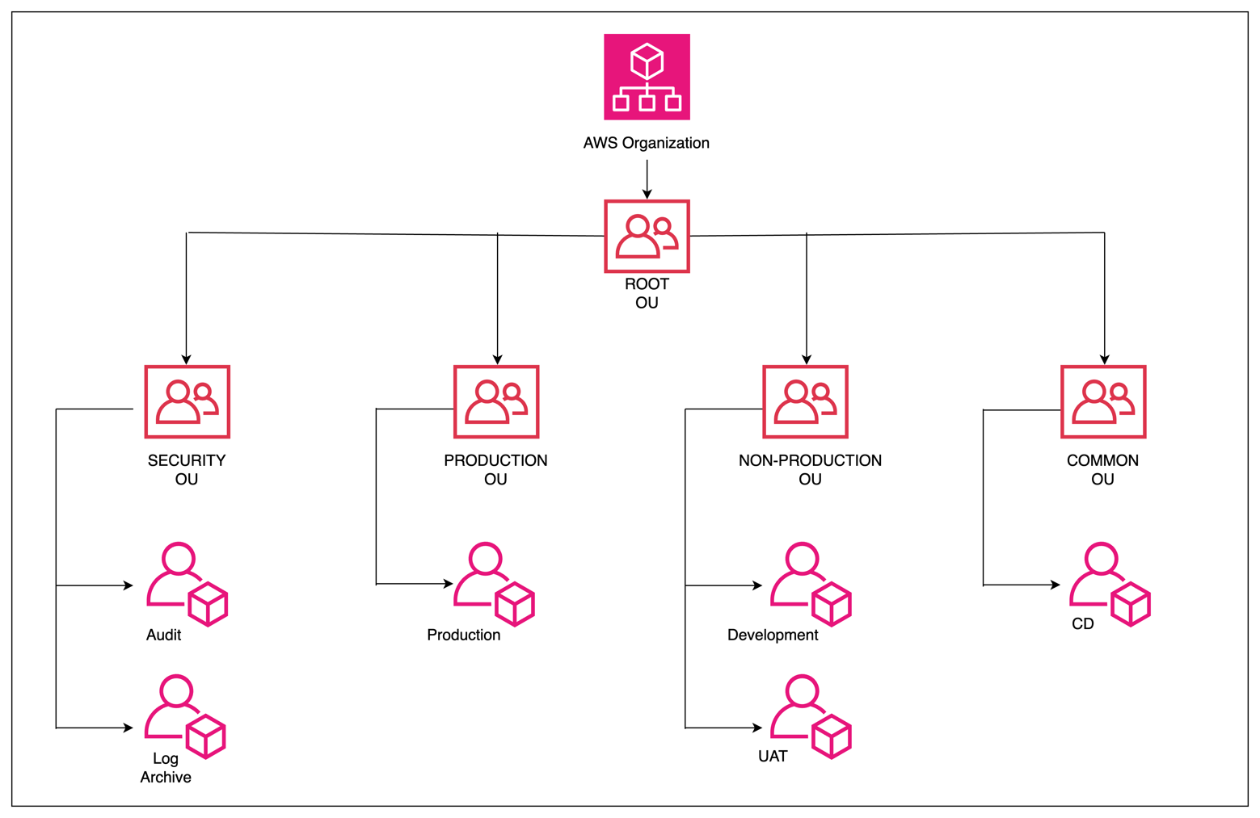
Figure 2: OU Structure

Management Account:
This is the AWS account that you use to create your organization and that becomes the owner of all the other accounts in your organization. The master account has unique permissions, such as the ability to create and manage AWS accounts in the organization and enable consolidated billing across all accounts in the organization.
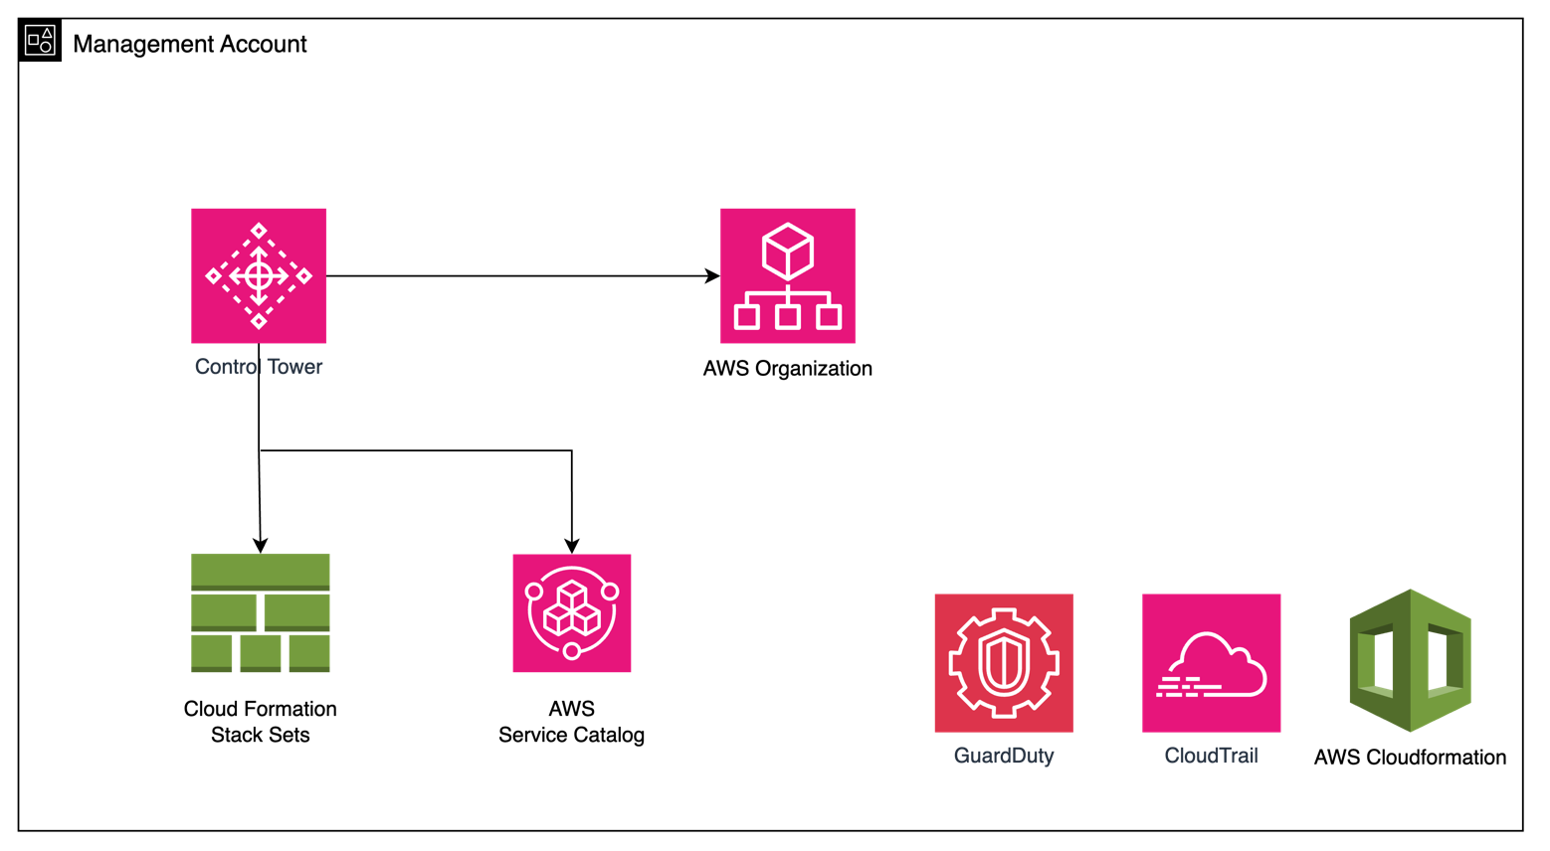
Figure 3: Management Account

This Management account serves several critical functions within the landing zone environment.

- Billing Consolidation: One of the primary roles of the management account is to consolidate the billing of all accounts within the landing zone. By centralizing billing, organizations gain better visibility and control over their AWS spending, facilitating cost optimization efforts and budget management across multiple accounts.

- Account Provisioning: The management account is responsible for provisioning new AWS accounts within the landing zone. This includes setting up the necessary configurations, policies, and security measures to ensure consistency and compliance with organizational standards. Account provisioning is streamlined and automated, reducing manual overhead and accelerating the deployment of new resources and workloads.

- Organizational Unit (OU) Management: Within the landing zone's AWS Organization, the management account oversees the management of organizational units (OUs). OUs provide a hierarchical structure for organizing and managing AWS accounts, facilitating centralized governance and policy enforcement. The management account can create, modify, and delete OUs as needed to align with organizational requirements and structure.

- Guardrail Management: Guardrails are automated policies implemented within Control Tower to enforce security, compliance, and operational best practices across the AWS environment. The management account administers these guardrails, configuring and customizing them to align with specific security and compliance requirements. By centrally managing guardrails, organizations can ensure consistent enforcement of policies and mitigate risks effectively.

Root OU:
This is the highest level in your organization's hierarchy. The root OU contains every other account and OU in your organization, and you apply service control policies (SCPs) here to affect the entire organization.

Production OU
Organizational Unit designated for hosting all production workloads.

Non-Production OU
Organizational Unit designated for hosting all non-production workloads.

Common OU
This OU is used for accounts that provide shared services (like Active Directory, DNS, CI/CD, Networking components etc.) to other accounts in the organization. It is a centralized place for services that are used across multiple workloads.
Adrenalin DEIT, will use this OU to have a dedicated CD Account to host centralized AWS ECR repositories.

Security OU
The Core OU forms the backbone of an AWS Organization, providing a foundational layer for governance, security, and efficient resource management across all AWS accounts within the organization.

Control Tower offers to include default accounts within the Security OU. These default accounts serve specific purposes, aiding in essential functions like logging, auditing, and governance. Two such default accounts are "log-archive" and "audit account."

- Log Archive Account: The "log-archive" account is dedicated to storing and managing log data generated by various services and resources deployed within the AWS environment. It serves as a centralized repository for logs, including CloudTrail logs, VPC Flow Logs, and other application logs. By consolidating logs in a dedicated account, organizations can ensure data integrity, security, and compliance with regulatory requirements. Additionally, separating log storage from operational accounts enhances operational resilience and simplifies log management processes.

- Audit Account: The "audit account" is specifically designed for auditing and monitoring activities within the AWS environment. It facilitates centralized monitoring of account activity, resource changes, and configuration drift across member accounts. By consolidating audit logs and implementing automated monitoring solutions, organizations can enhance security posture, detect anomalous behaviour, and respond promptly to security incidents or policy violations. The audit account plays a crucial role in maintaining transparency, accountability, and compliance with internal policies and industry regulations.

For Adrenalin DEIT, Security OU will be deployed with default log archive and audit accounts.

Adrenalin DEIT Organizational Units
Here is a brief description of the core accounts depicted in the above diagram.

Account Details
Account Name | Account Description
Management Account | This is the AWS account that you use to create your organization and manage other accounts. It's used to manage global resources and services, like AWS Organizations, IAM, and Control Tower.
Log archive (logging) | This account contains a centralized storage location for copies of every account’s audit, configuration compliance, and operational logs. It also provides a storage location for any other audit/compliance logs, as well as application/OS logs.  This account comes under Security OU.
Audit | This account is used to provide centralized delegated admin access to AWS security tooling and consoles, as well as provide view-only access for investigative purposes into all accounts in the organization.  This account comes under Security OU.
Development | This account is dedicated to provision development environment workloads. It is a part of Non-Production OU.
UAT | This account is dedicated to provision UAT environment workloads. It is a part of Non-Production OU.
Production | This account is dedicated to provision production environment workloads. It is a part of Production OU.
CD | This account is designated for hosting the ECR repos centrally. It is a part of Common OU.

Email Addresses
Account Name | Email Address
Management Account | masterpayer-10080751@accounts.manage.rackspace.com
Log archive (logging) | deit.archive@adrenalinmedia.com.au
Audit | deit.audit@adrenalinmedia.com.au
Development | deit.dev@adrenalinmedia.com.au
UAT | deit.uat@adrenalinmedia.com.au
Production | deit.prod@adrenalinmedia.com.au
CD | deit.cd@adrenalinmedia.com.au

Environments
Environment Name | Account Description
Production | This account aims to manage all production ready workloads.
UAT | This account aims to manage all UAT ready workloads.
Development | This account aims to manage all development workloads.

Naming convention

Account Names
The adopted naming conventions will follow Rackspace standards.

Containers/Compute

Elastic Container Service (ECS)
Resource | Format | Example
Cluster | {identifier}-{env}-{type} | deit-dev-businessLogic
Service | {identifier}-{env}-{type} | deit-dev-backend

Application Load Balancer
Resource | Format | Example
LB | {identifier}-{env}-{type} | deit-dev-lb

Networking

Virtual Private Cloud (VPC)
Resource | Format | Example
VPC | {identifier}-{env}-{type} | deit-dev-vpc
Subnet | {identifier}-{env}-{type}{count}-{zone} | deit-dev-subnet-public2-ap-southeast-2b
Route Tables | {identifier}-{env}-{type}{count}-{zone} | deit-dev-rtb-private1-ap-southeast-2b
Security Groups | {identifier}-{env}-{type} | deit-dev-sg

Storage

Simple Storage Service (S3)
Resource | Format | Example
S3 bucket | {identifier}-{env}-{type} | deit-dev-s3-terraform

Default Naming
Resource | Format | Example
Miscellaneous | {identifier}-{env}-{type} | deit-dev-db

Identity & Access Management
In managing access to resources and services within AWS, Identity and Access Management ans Identity Centre serves as a cornerstone for security and governance. IAM and Identity Center enable organizations to control who can access AWS resources and what actions they can perform.

Adrenalin DEIT will utilize AWS Single Sign-On (SSO) as the centralized identity management solution. AWS SSO simplifies the process of managing access to multiple AWS accounts and business applications by allowing users to sign in with their existing corporate credentials. However, in this setup, Adrenalin will leverage AWS SSO to create users natively within AWS SSO without integrating with any external identity providers.

Key Aspects of the Approach:

- AWS SSO User Creation:
  - Users will be created directly within AWS SSO. By using AWS SSO natively, we streamline user management and reduce the complexity of maintaining an additional identity infrastructure.

- Permission Sets for Access Control:
  - Permission Sets: AWS SSO will use permission sets to manage and assign permissions to users. Permission sets are collections of IAM policies that define what users can do within their assigned AWS accounts. By applying permission sets, we can ensure that users have the appropriate level of access based on their roles and responsibilities.
  - Permission sets offer flexibility and granularity in defining access controls, enabling the Adrenalin to implement the principle of least privilege and enhance security.
Benefits of Using AWS SSO and Permission Sets:
- Simplified User Management: By creating and managing users directly within AWS SSO, we can avoid the complexities associated with integrating and synchronizing with external identity providers. This leads to a more straightforward and efficient user management process.
- Centralized Access Control: AWS SSO provides a centralized platform for managing access to multiple AWS accounts.
- Flexible and Granular Permissions: Permission sets allow for the creation of tailored IAM policies that can be applied to users or groups. This flexibility ensures that users have the exact permissions they need, enhancing both security and productivity.
- Improved Security Posture: By using permission sets to enforce the principle of least privilege, the client can minimize the risk of unauthorized access and potential security breaches. Each user receives only the permissions necessary for their role, reducing the attack surface.

Networking

The AWS worldwide infrastructure consists of regions and, within those regions, are availability zones. Adrenalin DEIT will be utilizing all the availability zones in the below region.
Region | Availability Zones
ap-southeast-2 | ap-southeast-2a
ap-southeast-2 | ap-southeast-2b

VPC
Amazon Virtual Private Cloud (Amazon VPC) enables you to launch Amazon Web Services resources into a virtual network you've defined. This virtual network resembles a traditional network that you'd operate in your own data centre, with the benefits of using the scalable infrastructure of AWS. All the entities of the Adrenalin DEIT would create their resources under a VPC of its own.
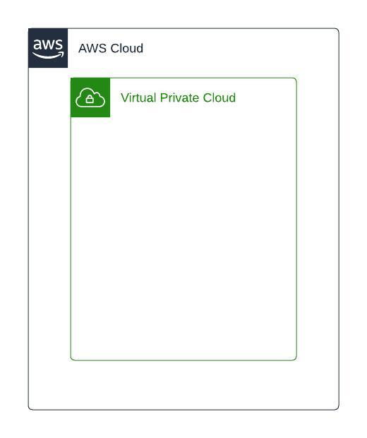

Private Subnet
Subnet is a logical segregation of VPC and is created under a VPC and private subnet is where any internal application which must be accessed within the VPC will be created. All the resources deployed within the private subnet will not be accessible from internet.
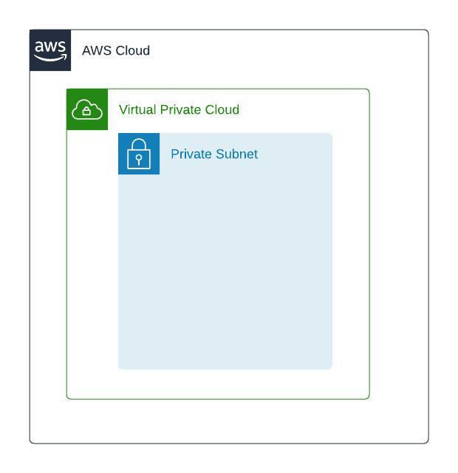

Internet Gateway
Internet gateway is a resource type in AWS which is used to provide internet access to the VPC and can be attached at a VPC level.
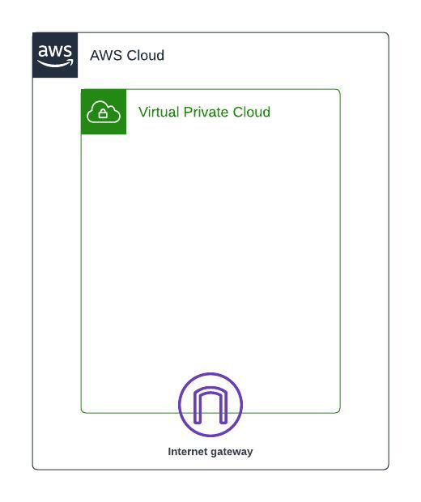

Public Subnet
A subnet can be created as a public if there is a route to internet via internet gateway. Any Internet facing application for Adrenalin DEIT will be deployed in the public subnet.
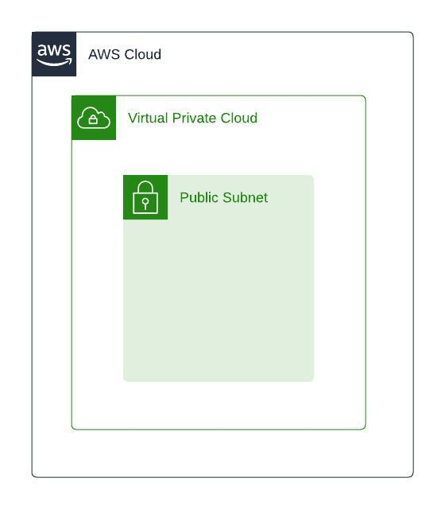

Availability zones
Availability Zones consist of one or more discrete data centers, each with redundant power, networking, and connectivity, and housed in separate facilities. These Availability Zones enable you to operate production applications and databases that are more highly available, fault tolerant, and scalable than possible when using a single data center. You can deploy your applications and databases across multiple Availability Zones. In the unlikely event of a failure of one Availability Zone, user requests are routed to your application instances in the second Availability Zone. This approach ensures that your application continues to always remain available.

Application in Adrenalin DEIT will be created in multi availability zones in Sydney region.

VPC
Below are the details of the VPCs to be created in various AWS accounts:

Account Name | VPC Name | VPC CIDR
Development | deit-dev-vpc | 10.0.0.0/20
UAT | deit-uat-vpc | 10.1.0.0/20
Production | deit-prod-vpc | 10.2.0.0/20

Subnets

Account | VPC Name | Subnet Name | Subnet Type | Subnet CIDR | AZ | Host  Count
Development | deit-dev-vpc | deit-dev-subnet-public1-ap-southeast-2a | Public | 10.0.0.0/24 | A | 254
Development | deit-dev-vpc | deit-dev-subnet-public2-ap-southeast-2b | Public | 10.0.1.0/24 | B | 254
Development | deit-dev-vpc | deit-dev-backend-subnet-private1-ap-southeast-2a | Private | 10.0.2.0/24 | A | 254
Development | deit-dev-vpc | deit-dev-backend-subnet-private2-ap-southeast-2b | Private | 10.0.3.0/24 | B | 254
Development | deit-dev-vpc | deit-dev-db-subnet-private3-ap-southeast-2a | Private | 10.0.4.0/24 | A | 254
Development | deit-dev-vpc | deit-dev-db-subnet-private4-ap-southeast-2b | Private | 10.0.5.0/24 | B | 254
UAT | deit-uat-vpc | deit-uat-subnet-public1-ap-southeast-2a | Public | 10.1.0.0/24 | A | 254
UAT | deit-uat-vpc | deit-uat-subnet-public2-ap-southeast-2b | Public | 10.1.1.0 /24 | B | 254
UAT | deit-uat-vpc | deit-uat-backend-subnet-private1-ap-southeast-2a | Private | 10.1.2.0 /24 | A | 254
UAT | deit-uat-vpc | deit-uat-backend-subnet-private2-ap-southeast-2b | Private | 10.1.3.0 /24 | B | 254
UAT | deit-uat-vpc | deit-uat-db-subnet-private3-ap-southeast-2a | Private | 10.1.4.0 /24 | A | 254
UAT | deit-uat-vpc | deit-uat-db-subnet-private4-ap-southeast-2b | Private | 10.1.5.0 /24 | B | 254
Production | deit-prod-vpc | deit-prod-subnet-public1-ap-southeast-2a | Public | 10.2.0.0/24 | A | 254
Production | deit-prod-vpc | deit-prod-subnet-public2-ap-southeast-2b | Public | 10.2.1.0/24 | B | 254
Production | deit-prod-vpc | deit-prod-backend-subnet-private1-ap-southeast-2a | Private | 10.2.2.0/24 | A | 254
Production | deit-prod-vpc | deit-prod-backend-subnet-private2-ap-southeast-2b | Private | 10.2.3.0/24 | B | 254
Production | deit-prod-vpc | deit-prod-db-subnet-private3-ap-southeast-2a | Private | 10.2.4.0/24 | A | 254
Production | deit-prod-vpc | deit-prod-db-subnet-private4-ap-southeast-2b | Private | 10.2.5.0/24 | B | 254

Tagging Strategy
Amazon Web Services allows assigning metadata to their AWS resources in the form of tags. Each tag is a simple label consisting of a customer-defined key and an optional value that can make it easier to manage, search for, and filter resources. Although there are no inherent types of tags, they enable Adrenalin to categorize resources by purpose, owner, environment, or other criteria.

General Best Practices:
- Always use a standardized, case-sensitive format for tags, and implement it consistently across all resource types.
- Consider tag dimensions that support the ability to manage resource access control, cost tracking, automation, and organization.
- Implement automated tools to help manage resource tags.
- Tags should be added to all resources (e.g., instances, volumes, databases, etc) that can be tagged.

Tagging strategy is a way to define and group your that are specific to your organization for standardization. We recommend Adrenalin to follow Rackspace standards for tagging resources:

Rackspace recommends following the Tagging Strategy below in each of the groups.

Tag Group | Tag | Description
Business | Owner | Specifies the individual or team responsible for the resource. This could be an email address, a name, or a team identifier, aiding in identifying who to contact for issues or questions related to the resource.
Technical | Environment | Describes the stage in the development lifecycle that the resource is part of, such as 'Development', 'Testing', 'Staging', or 'Production'. This helps in differentiating resources based on their deployment environment.
Automation | Terraform | Indicates whether the resource was provisioned using Terraform. This can be a simple 'Managed by Terraform' note or a more detailed description, useful for infrastructure as code (IaC) management and identifying resources managed through code.
 | Name | Provides a human-readable name for the resource, which can be used for easy identification. This is often set to a value that succinctly describes the resource, such as 'UserDatabase'.  This Name should follow the naming convention discussed in section 4.

Logging and Monitoring

Introduction

Early-stage provisioning of logging processes and performance monitoring is recommended to ensure the long-term success of the Cloud project. AWS services provide wide-ranging monitoring and logging of the resources to grant awareness and visibility across the platform.
AWS CloudWatch is a monitoring and observability service provided by Amazon Web Services (AWS) that provides data and actionable insights for AWS, hybrid, and on-premises applications and infrastructure resources.

Adrenalin DEIT will use CloudWatch for logging and monitoring. Standard dashboards will be created for each environment.

Backup

Available Services Overview

AWS does have a Backup-as-a-Service mechanism in the form of AWS Backup. AWS Backup is a fully managed backup service that makes it easy to centralize and automate data backup across AWS services in the cloud and on-premises.

Adrenalin DEIT will use AWS Backup service to perform daily backups of their database within the same AWS account and region. These backups will be retained for 30 days, ensuring data availability and protection while maintaining a straightforward and efficient backup management process.

Infrastructure as Code
Infrastructure as Code (IaC) revolutionizes the way infrastructure is managed and deployed within organizations by treating infrastructure configurations as code. Instead of manually configuring servers and resources, IaC enables automation and consistency using declarative templates. By codifying infrastructure configurations, organizations can achieve faster deployments, improved scalability, and enhanced reproducibility across environments.

Adrenalin DEIT will use Terraform OSS as infrastructure as code coupled with terraform pipelines. These pipelines automate the provisioning of infrastructure using Terraform configurations stored in version-controlled repositories on Bitbucket.

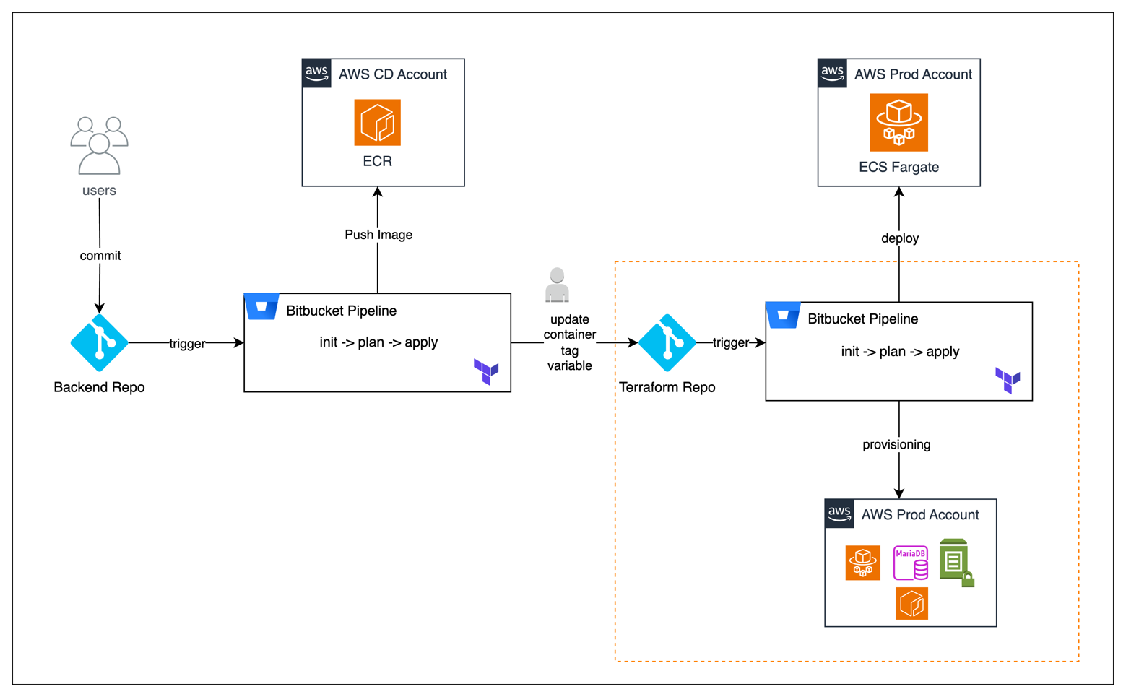
Figure 4: Deployment workflow

Execution Flow
1. Commit to Backend Repo:
- Action: A user commits changes to the Backend Repo.
- Trigger: This commit triggers the Bitbucket pipeline configured in the Backend Repo.
- Pipeline Steps:
  - Build Container Image: The pipeline builds a Docker container image based on the committed code.
  - Push to ECR: The built container image is pushed to the Elastic Container Registry (ECR) in the Continuous Deployment (CD) account.
2. Manual Update of Container Tag Variable:
- Action: After the container image is successfully pushed, the user manually updates the container tag variable in the Terraform Repo with the new image tag generated from the previous step.
- Purpose: This step ensures that the correct container image is deployed to the appropriate environment (Dev, UAT, Prod).
3. Trigger Bitbucket Pipeline in Terraform Repo:
- Trigger: The manual update of the container tag variable in the Terraform Repo triggers the Bitbucket pipeline configured in this repo.
- Pipeline Steps:
  - Terraform Init: Initialize Terraform to download necessary plugins and modules.
  - Terraform Plan: Generate and display an execution plan to preview the changes that Terraform will make to the infrastructure.
  - Terraform Apply: Apply the execution plan to provision or update the infrastructure on ECS Fargate.
4. Infrastructure Provisioning:
- Action: The Terraform pipeline in the Terraform Repo provisions infrastructure in the workload accounts (Dev, UAT, Prod).
- Directory Structure: Code for each account is placed in dedicated directories within the Terraform Repo:
  - terraform-repo/dev
  - terraform-repo/uat
  - terraform-repo/prod
- Execution:
  - Depending on the environment being targeted, the pipeline will navigate to the appropriate directory (dev, uat, or prod) and execute the terraform init, terraform plan, and terraform apply commands.

Resource Specification
Resource | Category | Parameter | Value – Dev/UAT | Value - Prod
ECS Fargate | Cluster | Cluster Name | deit-dev-business-logic | deit-prod-business-logic
ECS Fargate | Cluster | Region | ap-southeast-2 | ap-southeast-2
ECS Fargate | Task Definition | Task Definition Name | deit-{env}-backend-task-definition-family | deit-prod-backend-task-definition-family
ECS Fargate | Task Definition | Container Name | deit-{env}-backend | deit-prod-backend
ECS Fargate | Task Definition | Image | 975049968666.dkr.ecr.ap-southeast-2.amazonaws.com/deit-backend:<tag> | 975049968666.dkr.ecr.ap-southeast-2.amazonaws.com/deit-backend:<tag>
ECS Fargate | Task Definition | Logging Configuration | /ecs/deit-backend-task-definition-family | /ecs/deit-backend-task-definition-family
ECS Fargate | Service | Service Name | deit-{env}-backend | deit-prod-backend
ECS Fargate | Service | Desired Count | 1 | 2
ECS Fargate | Service | Load Balancer Name | deit-{env}-lb | deit-prod-lb
ECS Fargate | Service | Health Check Configuration | “/” | “/”
ECS Fargate | Service | VPC | deit-{env}-vpc | deit-prod-vpc
ECS Fargate | Service | Subnet | deit-{dev} -backend-subnet-private1-ap-southeast-2a,  deit-{env} -backend-subnet-private2-ap-southeast-2b | deit-prod-backend-subnet-private1-ap-southeast-2a,  deit-{env} -backend-subnet-private2-ap-southeast-2b
ECS Fargate | Service | Min Task Count | 1 | 2
ECS Fargate | Service | Max Task Count | 1 | 4
Maria DB | DB Instance | DB Instance Identifier | deit-{dev} -database | deit-prod-database
Maria DB | DB Instance | DB Instance Class | db.t3.small | db.t3.medium
Maria DB | DB Instance | Engine | MariaDB | MariaDB
Maria DB | DB Instance | Engine Version | 10.11.6 | 10.11.6
Maria DB | DB Instance | Allocated Storage | 50 GB | 50 GB
Maria DB | DB Instance | Storage Type | General Purpose SSD (gp3) | General Purpose SSD (gp3)
Maria DB | DB Instance | Multi-AZ Deployment | No | Yes
Maria DB | Network and backup Configuration | VPC | deit-{env}-vpc | deit-prod-vpc
Maria DB | Network and backup Configuration | Subnets | deit-{env} -db-subnet-private3-ap-southeast-2a,  deit-{env} -db-subnet-private4-ap-southeast-2b | deit-prod-db-subnet-private3-ap-southeast-2a,  deit-prod-db-subnet-private4-ap-southeast-2b
Maria DB | Network and backup Configuration | Security Group | Allow traffic within the vpc,  Only NAT Gateways in public subnet can access internet gateway,  Backend service is exposed via Application Load Balancer | Allow traffic within the vpc,  Only NAT Gateways in public subnet can access internet gateway,  Backend service is exposed via Application Load Balancer
Maria DB | Network and backup Configuration | Master Username | admin | admin
Maria DB | Network and backup Configuration | Master Password | (stored in Secrets Manager) | (stored in Secrets Manager)
Maria DB | Network and backup Configuration | Parameter Group | default.mariadb10.11 | default.mariadb10.11
Maria DB | Network and backup Configuration | Option Group | default:mariadb-10-1 | default:mariadb-10-1
Maria DB | Network and backup Configuration | Backup Retention Period | Daily – 7 days Retention | Daily – 30 days Retention
Maria DB | Network and backup Configuration | Backup Window | AWS Default  12.30 AM Sydney Time | AWS Default  12.30 AM Sydney Time
Maria DB | Monitoring and Maintenance | Performance Insights | Disabled | Disabled
Maria DB | Monitoring and Maintenance | Deletion Protection | Disabled | Enabled
Maria DB | Monitoring and Maintenance | Auto Minor Version Upgrade | Enabled | Enabled
Maria DB | Replication | Read Replicas | NA | NA
Maria DB | Replication | Replication Source | NA | NA

Exclusions
- AWS multi-account structure (Control Tower) will be provisioned manually and NOT covered by Terraform
- Compliance policy review
- Infrastructure implementation outside of defined scope to align with compliance policies
- Training or detailed documentation on how Terraform, AWS services and other tools functions
- Cloudflare Pages design and implementation
- SSO integration with identity provider for AWS accounts
- Application configuration and testing
- Application code development, configuration and testing
- APM installation and configuration
- Data migration
- Performance testing, penetration testing and any application-level functional testing
- Integration with customer issue tracking tools
- Integration with 3rd party tools & services
- IPSec VPN for hybrid cloud
- Non-standard AWS rules for WAF are out of scope

